**Abstract**

For project #2, we will be focusing on homelessness in the United States from 2007 to 2016. Since 2007, there has been an inflation within the homeless population. We were inspired to focus on a serious topic that continues to affect many Americans daily. In the recent years, each state has taken a different approach on state resources for the homeless community, but the growth of the community continues to be a trend. In Seattle, there are several resources for the homeless community but the is still are large population within the homelessness community. As for New York City, resources have been extremely reduced and the amount of people in the homeless community is at large as well. We are interested in viewing the overall population per state along with the condition of the homeless community in a certain time frame. During this process, we will be making comparisons between states and the types of conditions of the homeless population such as sheltered, unsheltered, individuals, and families. Our goal is to shine light on some of the challenges the states are still facing in this topic.

**Sketch**

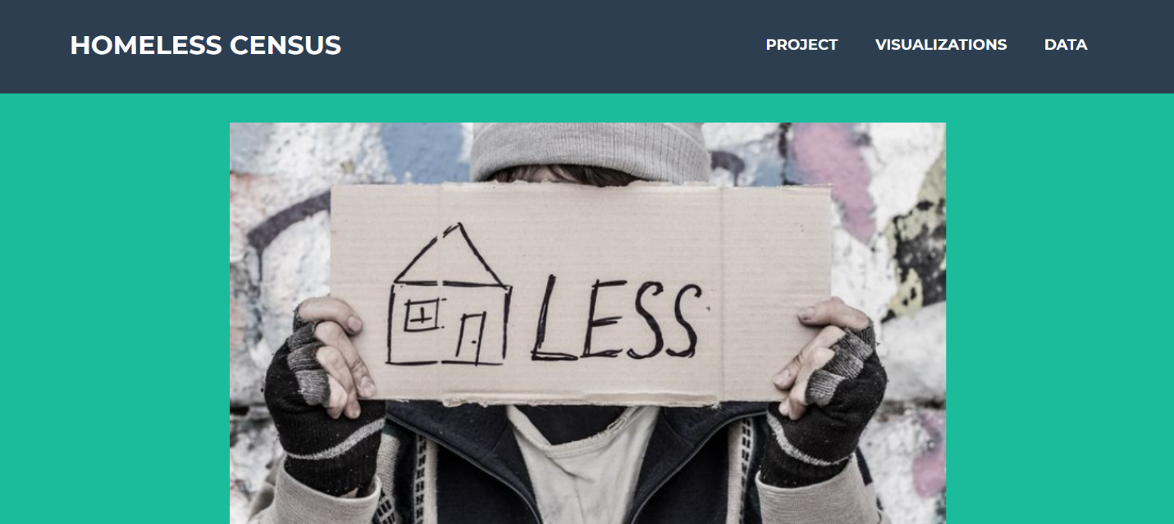

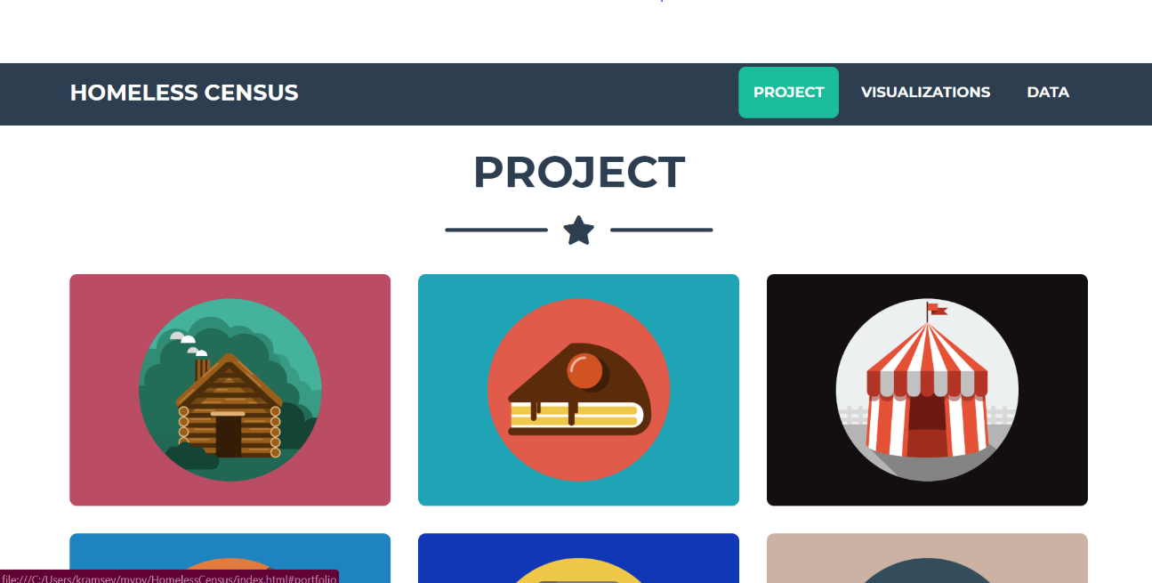

**Visualizations**

